# Positive Prompt

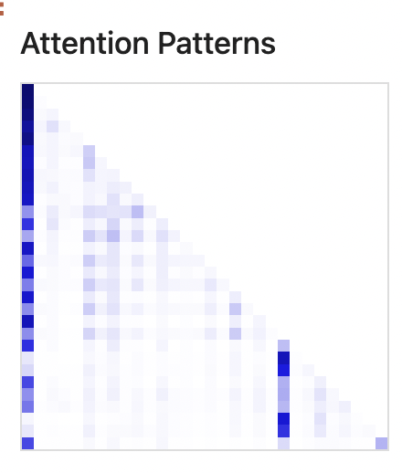

I embrace the eightfold journey ('correct perspective, motivation, communication, behavior, career, diligence, awareness, and focus') taught by the Sage

# Negative Prompt

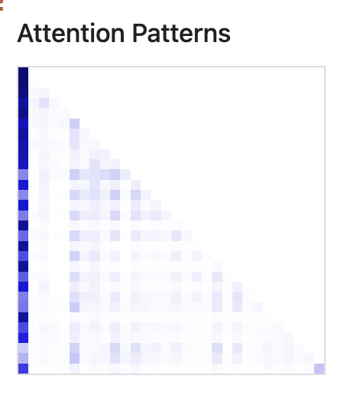

I embrace the eightfold journey ('correct perspective, motivation, communication, behavior, career, diligence, awareness, and focus') taught by the Sage

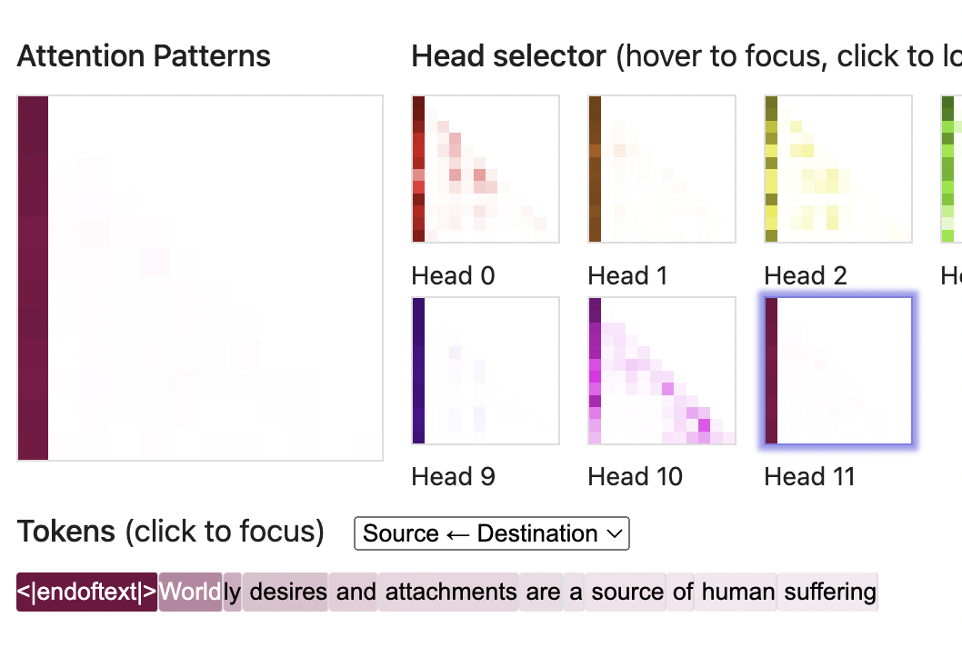

Head 11 is unused here

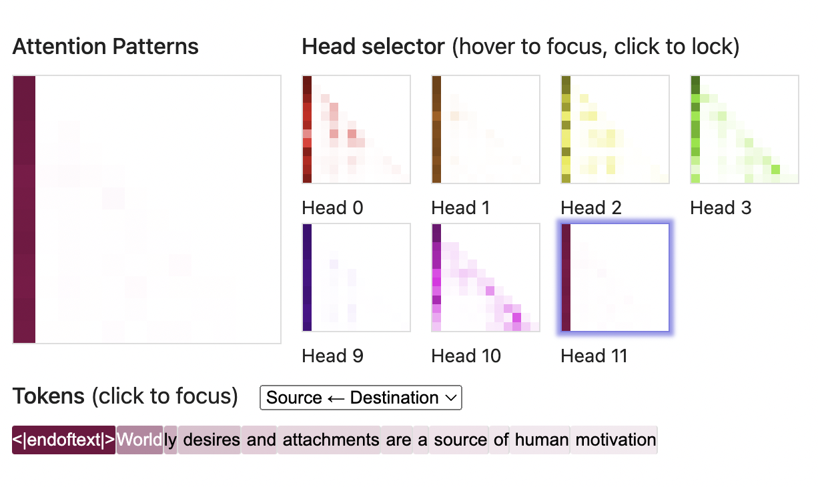

Likewise

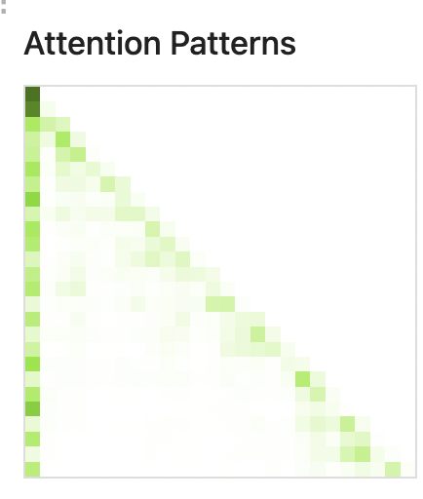

I believe that life is suffering caused by attachment and the only way to escape from suffering is to let go of one's attachment

Comment: Heads 3 and 11 are induction heads with some noise



I believe that life is challenging caused by circumstances and the only way to overcome challenges is to face them head-on